PREMIER COMMUNITY CARE NEWSLETTER
  - Issue No. 1 18th June 2024
PLEASE JOIN US IN WISHING MANY HAPPY RETURNS TO PEOPLE CELEBRATING THEIR BIRTHDAY THIS WEEK
Clara Harris
Paul Barrett
Lillian Nash
Anne Robinson
June Moore

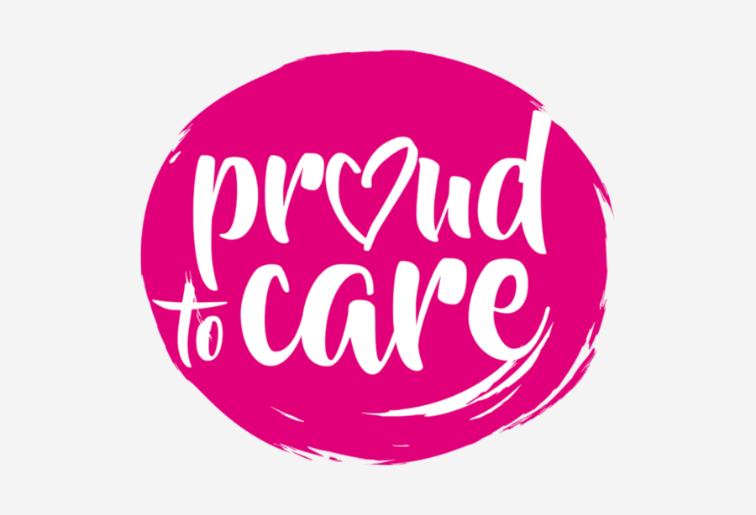

WELCOME TO OUR NEW NEWSLETTER
Hello and welcome to Premier Community Care to our clients and their families and to all of our wonderful carers.

CARER TEAM MEETINGS
Our Carer Team Meetings are held on the last Wednesday of every month. Our next Carer Team Meeting will be held on Wednesday 26th June 2024 from 2:30pm to 3:30pm we really hope you can attend. It will be a chance for you to come along to the Premier office and have a chat and a cuppa with the management team.

COMPLIMENT YOUR CARER
If you think your carer is doing a wonderful job please let them know, everyone likes to hear something nice being said about them!

Our clients are at the center of everything we do
We, at Premier Community Care, are proud to serve our clients in the community and we appreciate and respect every individual. We endeavor to resolve any issues promptly and effectively with an emphasis on continuous improvements. Our monthly quality assurance telephone call checks are a great way for Premier Community Care to find out what we can improve on and what we are doing well. Below is an example of a recent compliment we received from one of our clients.

“I am very happy with the regular carers that have been coming to see my wife, Alison Smith and Sarah Smirthwaite”

EMPLOYEE YEARS OF SERVICE MILESTONES
Please join us in congratulating and most importantly thanking the employees listed below for their years of service to Premier Community Care:
Susan Ashley for 2 years of service.
Rhona-Lee Hamilton for 1 year of service.
Zoe Peacock for 7 years of service.

HAVE YOUR SAY


Contact Us
Premier Community Care
Unit 26 Innovation House
Bishop Auckland
County Durham
DL14 6XB

01388 458991
Premiercommunitycare.co.uk

We welcome all feedback from our clients, their families, friends and carers. If you have a great idea or can think of any improvements we can make we are always here to listen, we would also like to hear from you if any of our carers have surpassed expectations or even if you just feel that a carer requires recognition then please contact us. Our contact details can be found below.

